**Shop Nest Store: Sales Performance Dashboard Report**

1. **Total Sales by Product Categories**

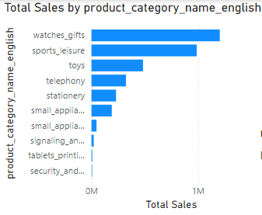

**Analysis:**

* The **bar chart** displays the top-performing product categories based on sales.
* **Watches & Gifts** are the top-selling category, indicating a strong market demand for these products.
* **Sports & Leisure** and **Toys** follow as the next top categories.
* Lower-performing categories include **Telephony** and **Stationery**.

**Insights:**

1. High-performing categories should be prioritized for stock, promotions, and bundling strategies to maximize revenue.
2. For **low-performing categories**, assess:
   * Demand and market need.
   * Pricing strategy.
   * Possible inventory issues.  
     Focus on discounts or marketing campaigns to drive sales in these categories.
3. **Delayed vs. On-Time Orders**

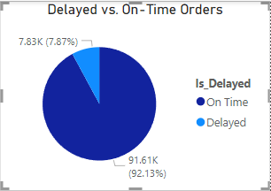

**Analysis:**

* The **pie chart** indicates that **92% of orders** are delivered **on time**, while **8%** are delayed.
* Though on-time delivery is dominant, **delayed orders** can impact customer satisfaction and loyalty.

**Insights:**

* Identify the **reasons for delays**:
  + Logistics issues?
  + Supplier delays?
  + Inadequate inventory?
* Implement strategies such as:
  + **Route optimization** for deliveries.
  + Partnering with reliable logistics providers.
  + Monitoring peak periods for better resource allocation.

1. **Order Count by Month-Year and Delivery Status**

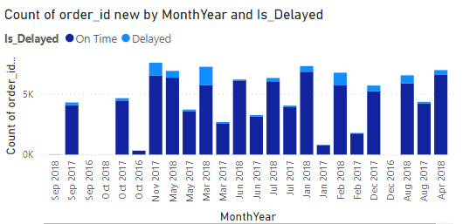

**Analysis:**

* The **bar chart** shows the number of orders across months, broken into **on-time** and **delayed** deliveries.
* Peaks in orders are visible in specific months like **September 2018**, **October 2017**, and **February 2018**.

**Insights:**

1. **Peak months** indicate higher demand:
   * Prepare inventory, workforce, and logistics in advance for these months.
2. Analyze the **reasons for fluctuations**:
   * Were promotions or holidays driving peaks?
   * Were operational challenges causing dips?
3. Focus on improving delivery times during peak months.
4. **Payment Method Analysis**

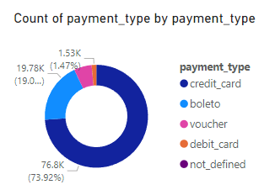

**Analysis:**

* **73.9%** of transactions use **credit cards**, making it the preferred payment method.
* Other methods like **boleto**, **debit cards**, and **vouchers** have significantly lower usage.

**Insights:**

1. Promote alternative payment methods:
   * Offer discounts or cashback for payments made through **debit cards** or **vouchers**.
2. Assess the reasons for the dominance of credit cards:
   * Are other methods difficult to use or not well-integrated?
3. Diversifying payment methods can attract a broader range of customers.
4. **Revenue Analysis (With Freight)**

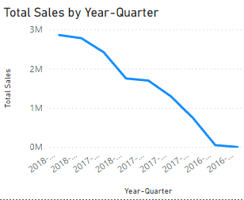

**Analysis:**

* The **line chart** shows revenue, including freight, trending **downwards** over time.
* The **highest revenue** was achieved in **early 2018**, but it started declining in subsequent quarters.

**Insights:**

1. Investigate reasons for the decline:
   * Reduced sales volume?
   * Increased competition?
   * Pricing changes?
2. Potential Solutions:
   * Offer promotions or bundle discounts to boost sales.
   * Focus on high-performing products and regions.
   * Optimize freight charges to make pricing attractive.
3. **Product Ratings**

**Analysis:**

* Average product ratings are consistently **4.07** across all categories, indicating high customer satisfaction.
* Categories like **Pet Shop**, **Kitchen Appliances**, and **Gifts** maintain this standard.

**Insights:**

1. Maintaining high product quality is crucial for sustaining these ratings.
2. Encourage customer reviews to increase transparency and trust.
3. Focus on categories where ratings might dip below **4.0** to improve the product or service.

**7. State-wise and City-wise Sales**

**Analysis:**

* **Top-performing cities** include **Xin Guara**, **Xexeu**, and **Xaxim**, which have contributed significantly to total sales.
* Smaller cities like **Zor tea** and **Ze Doka** have lower sales.

**Insights:**

1. **Focus on high-performing cities**:
   * Run targeted marketing campaigns in these cities to maintain strong sales.
2. **Explore smaller cities**:
   * Assess why sales are lower—lack of awareness, demand, or delivery challenges?
   * Introduce localized promotions and advertisements.

**8. Total Sales Trends**

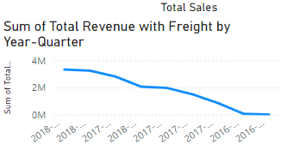

**Analysis:**

* The **line chart** shows a clear **downward trend** in total sales over the quarters.
* Sales peaked in early 2018 and gradually declined.

**Insights:**

1. Analyse why? sales are declining:
   * Were there fewer promotions or reduced customer engagement?
   * Did external factors like market saturation or competition affect performance?
2. Strategies to reverse the trend:
   * Introduce seasonal discounts or promotional campaigns.
   * Improve customer experience to drive repeat purchases.
   * Focus on best-selling products and profitable regions.

**9. Key Recommendations**

1. **Product Categories**:
   * Focus on high-performing products while improving marketing for low-selling items.
2. **Delivery Timeliness**:
   * Reduce delays by improving logistics and inventory management.
3. **Payment Methods**:
   * Promote alternatives to credit cards with discounts and cashback offers.
4. **Revenue Improvement**:
   * Investigate the downward trend in sales and introduce strategies to recover revenue.
5. **City-Wise Growth**:
   * Strengthen presence in top-performing cities while expanding to untapped regions.
6. **Customer Satisfaction**:
   * Maintain product quality to sustain ratings and build customer trust.